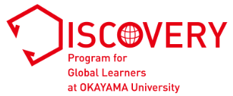
Personal Statement: Part A
Statement of Interest

Applicant’s full name:

Complete all sections in English. Respond to all questions. Part A and Part B should be written in an essay format.
Although you may consult teachers, counselors, and friends, all final writing must be your own words. If we find
plagiarism, including material copied from websites, your application will not be considered any further. If you
advance to the interview stage, you may be asked to answer questions or elaborate on your statement. Use 12-point font single-space (Times New Roman preferred).

Write a short essay of 450 to 500 words answering the following questions:
・ What are your current interest(s) and goal(s)?
・ What life experiences led you to your current interest(s) and goal(s)?
・ What is your proposed course of study (e.g., “Track”/“Cluster” of the Discovery Program) ?
・ How does your proposed course of study relate to your interest(s) and goal(s)?

Total word count:

