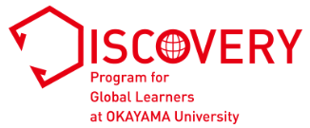
Personal Statement: Part B
Life Lesson
(if you have selected “Social Science & Humanities” as your first choice
in “10. Desired Area(s) of Study” in online application form)

Applicant’s full name:

Complete all sections in English. Respond to all questions. Part A and Part B should be written in an essay format.
Although you may consult teachers, counselors, and friends, all final writing must be your own words. If we find
plagiarism, including material copied from websites, your application will not be considered any further. If you
advance to the interview stage, you may be asked to answer questions or elaborate on your statement. Use 12-point font single-space (Times New Roman preferred).

Write a short essay of 450 to 500 words answering the following questions:
・ What has been the biggest challenge in your life?
・ How have you overcome/are you trying to overcome it?
・ What life lesson have you learnt from these experiences, and how/what can you contribute to others through this lesson?

Total word count:

