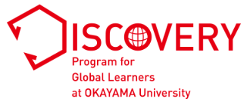
Personal Statement: Part A
Statement of Interest

Applicant’s full name:

Complete all sections in English. Respond to all questions. Part A and Part B should be written in an essay format.
Although you may consult teachers, counselors, and friends, all final writing must be your own words. If we detect
plagiarism, including material copied from websites or generative AI platforms, your application will not be considered any further. If you advance to the interview stage, you may be asked to answer questions or elaborate on your statement.
Use 12-point font single-space (Times New Roman preferred).

Write a short essay of 450 to 500 words in the designated space (one A4 sheet) answering all of the following questions and indicate the word count upon completion:
・ What is/are your current interest(s) and goal(s)?
・ What life experiences led you to your current interest(s) and goal(s)?
・ What is your proposed study plan? (see “Fields of Study” (pp. 18–19) in the Application Guide)?
・ How does your proposed course of study relate to your interest(s) and goal(s)?

Personal Statement: Part A
Statement of Interest

Total word count:

☐ I hereby declare that I did not engage in any form of plagiarism, including copying materials from websites or generative AI platforms, in my Personal Statement: Part A.

Name ___________________________________________ Date _____________________________

